**PROJECT**

**Computer Vision**

**Problem formulation:**

project involves training a convolutional neural network (CNN) for a binary classification task using a dataset of images. Our project aims to develop a model for predicting vitiligo on facial images. Specifically, the goal is to determine whether a given face is affected by vitiligo or not. Vitiligo is a skin condition characterized by the loss of pigmentation in certain areas of the skin, resulting in white patches.

To achieve this, we utilize a dataset of facial images, which is divided into a training set and a test set. The training set consists of images labeled as either "affected by vitiligo" or "not affected by vitiligo." We train a convolutional neural network (CNN) model using this labeled data to learn the patterns and features associated with vitiligo-affected faces.

**Project files:**

CV_Project_File(learning rate 0.01 and epochs 20)

**Results on learning rate 0.01 and Epochs 20**

**first fold:**

> Accuracy: 48.718

> Precision: 48.718

> Recall: 100.000

> F1 Score: 65.517

> Cross Entropy Loss: 0.696

**second fold:**

> Accuracy: 51.282

> Precision: 32.479

> Recall: 66.667

> F1 Score: 43.678

> Cross Entropy Loss: 0.706

**third fold:**

> Accuracy: 48.718

> Precision: 35.726

> Recall: 73.333

> F1 Score: 48.046

> Cross Entropy Loss: 0.707

**Average Accuracy:**

49.573

**Metrics for model evaluation:**

val_accuracy of fold # 1 : 0.38235294818878174

val_precision of fold # 1 : 0.38235294818878174

val_recall of fold # 1 : 1.0

val_AUC of fold # 1 : 0.5079670339822769

2/2 [==============================] - 1s 41ms/step

val_F1score of fold # 1 : 0.6799999999999999

val_accuracy of fold # 2 : 0.4045454666018486

val_precision of fold # 2 : 0.03030303120613098

val_recall of fold # 2 : 0.05 val_AUC of fold # 2 : 0.5

2/2 [==============================] - 1s 28ms/step

val_F1score of fold # 2 : 0.6799999999999999

val_accuracy of fold # 3 : 0.49696969985961914

val_precision of fold # 3 : 0.20606060028076173

val_recall of fold # 3 : 0.4

val_AUC of fold # 3 : 0.5

2/2 [==============================] - 1s 28ms/step

val_F1score of fold # 3 : 0.6799999999999999

**Generate the Train Test Error Learning Curve**

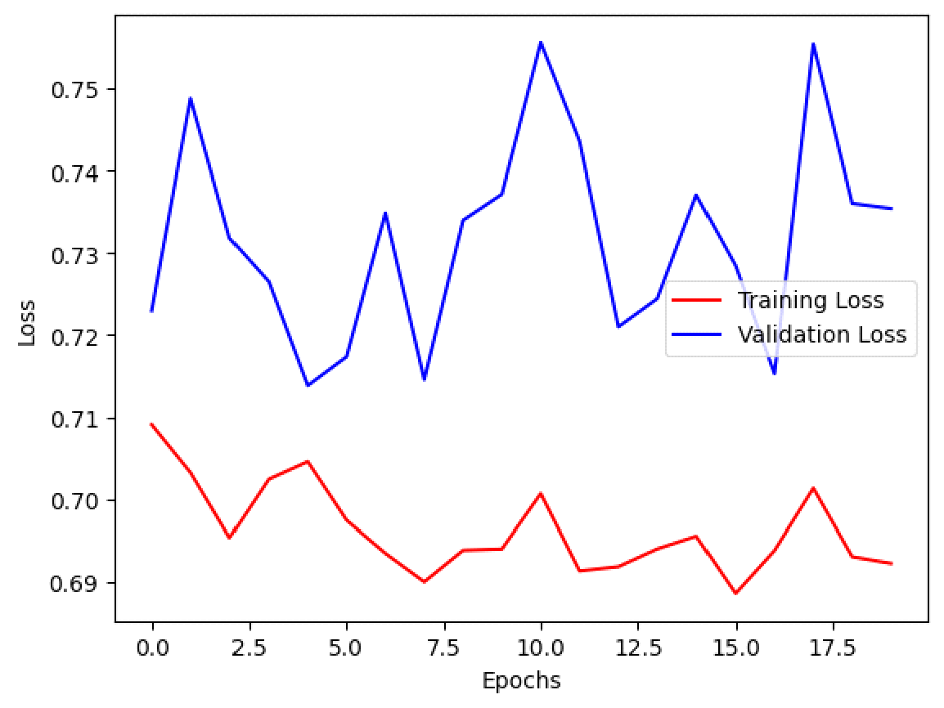

**Model summary after third fold:**

